https://openaicellular.github.io/oaic/oran_installation.html
sudo -i <------------------------Always do this command at first after you login to your vm
Clone vespamgr repo to build custom image

git clone "https://gerrit.o-ran-sc.org/r/ric-plt/vespamgr"

Edit config file to match IP Address and port

nano vespamgr/config/config-file.json
Replace - "prometheusAddr": "http://infra-cpro-server:80",
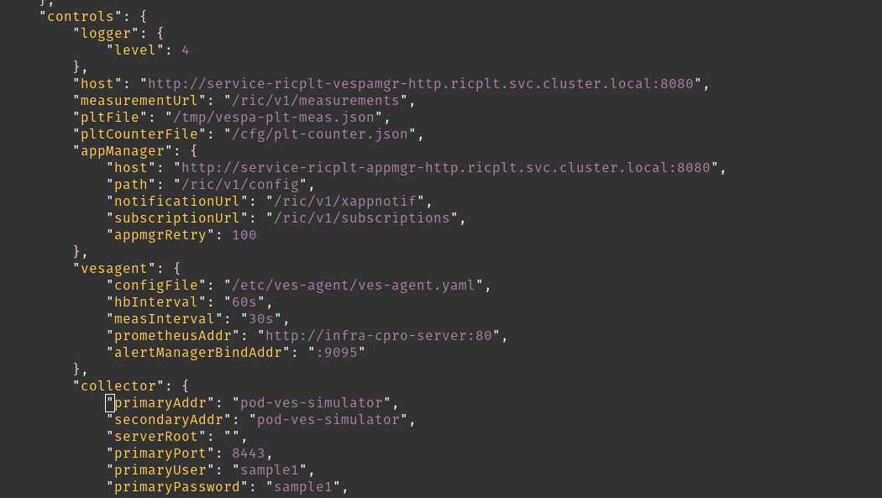
With - "prometheusAddr": "http://r4-infrastructure-prometheus-server.ricplt:80",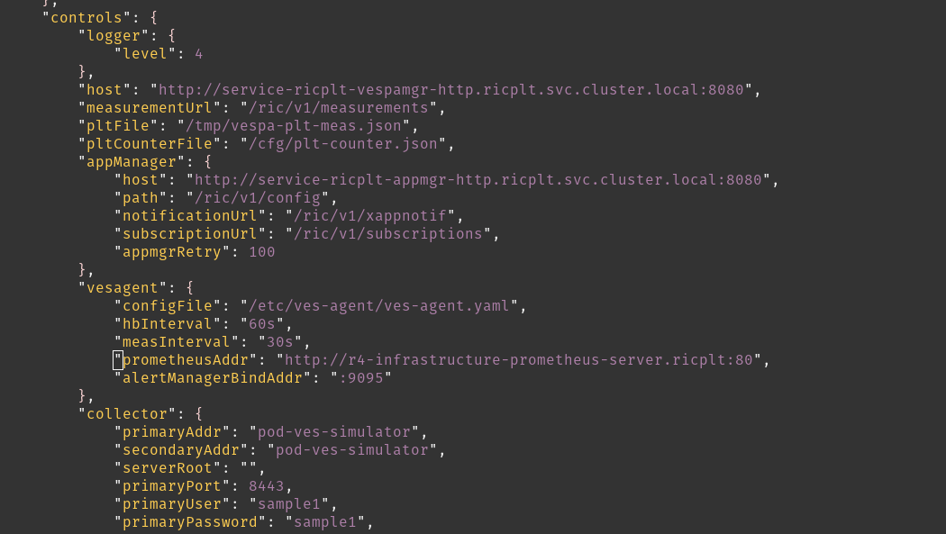

Replace-
"collector": {
"primaryAddr": "pod-ves-simulator",
"secondaryAddr": "pod-ves-simulator",
"serverRoot": "",
"primaryPort": 8443,
"primaryUser": "sample1",
"primaryPassword": "sample1",
"secure": false
}

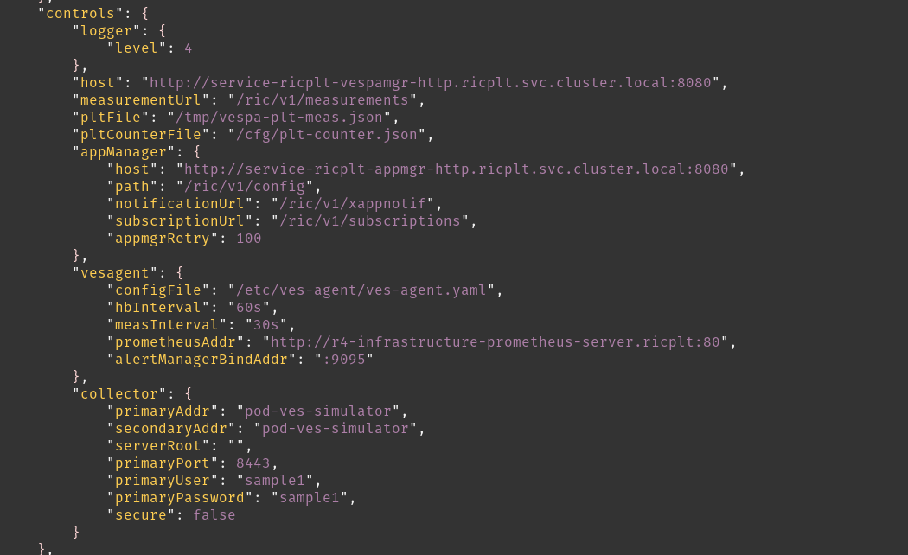
With -
"collector": {
"primaryAddr": "192.168.122.233",<--------------------YOUR MACHINE IP ADDRESS
"secondaryAddr": "192.168.122.233",<--------------------YOUR MACHINE IP ADDRESS
"serverRoot": "",
"primaryPort": 9999,<---------------------------------Changed
"primaryUser": "user",<---------------------------------Changed
"primaryPassword": "password",<---------------------------------Changed
"secure": false
}
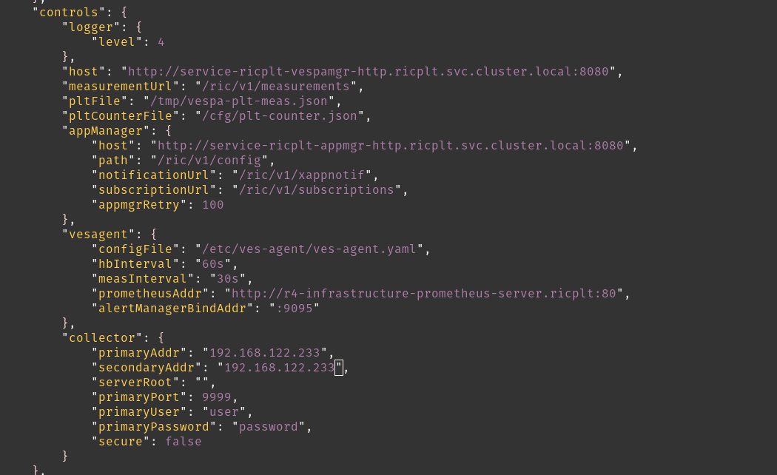

Build custom image and push to local repository

cd vespamgr/

sudo apt-get update && apt-get install -y apt-utils

docker build -t ric-plt-vespamgr:0.7.5 $PWD

docker push localhost:5000/ric-plt-vespamgr:0.7.5 <-------YOU MAY GET ERROR AS SHOWN BELOW

To Resolve you may TRY
docker run -d -p 5000:5000 --name registry registry:2

docker tag ric-plt-vespamgr:0.7.5 localhost:5000/ric-plt-vespamgr:0.7.5
docker push localhost:5000/ric-plt-vespamgr:0.7.5

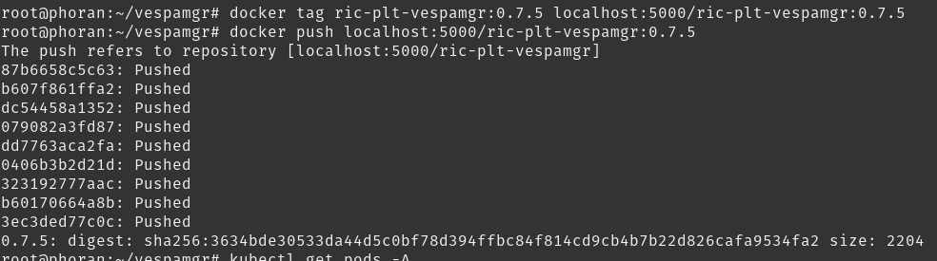

cd
git clone https://github.com/openaicellular/oaic.git
git submodule update --init --recursive

cd ~/oaic/RIC-Deployment/tools/k8s/bin
./gen-cloud-init.sh
sudo ./k8s-1node-cloud-init-k_1_16-h_2_17-d_cur.sh
sudo kubectl get ns ricinfra<-------------------(To check if ricinfa is already present or not if not create using bellow cmd)
sudo kubectl create ns ricinfra
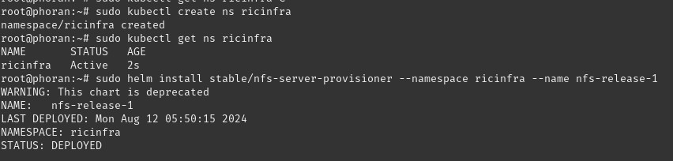
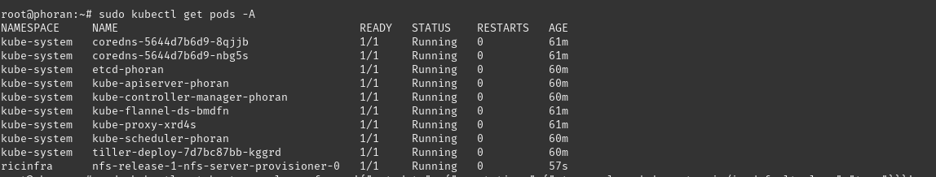

sudo helm install stable/nfs-server-provisioner --namespace ricinfra --name nfs-release-1

sudo kubectl patch storageclass nfs -p '{"metadata": {"annotations":{"storageclass.kubernetes.io/is-default-class":"true"}}}'

sudo apt install nfs-common

Build Modified E2 docker Image
sudo docker run -d -p 5001:5000 --restart=always --name ric registry:2

cd /root/oaic/RIC-Deployment/bin

cp ../RECIPE_EXAMPLE/PLATFORM/example_recipe_oran_e_release_modified_e2.yaml \
../RECIPE_EXAMPLE/PLATFORM/example_recipe_oran_e_release_modified_e2_vespa.yaml

Edit configs to pull from local repository
vim ../RECIPE_EXAMPLE/PLATFORM/example_recipe_oran_e_release_modified_e2_vespa.yaml
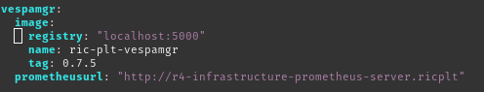

Edit configmaps to match username and password and port as done for vespamgr above

vim ../ric-dep/helm/vespamgr/templates/vespa-config.yaml

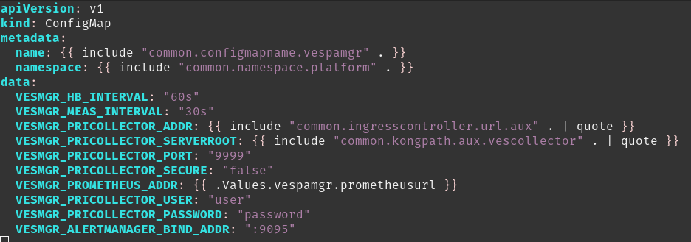

Deploy the near-Real Time RIC
cd ~/oaic/RIC-Deployment/bin
sudo ./deploy-ric-platform -f ../RECIPE_EXAMPLE/PLATFORM/example_recipe_oran_e_release_modified_e2_vespa.yaml

kubectl get pods -A